Dataset statistics:

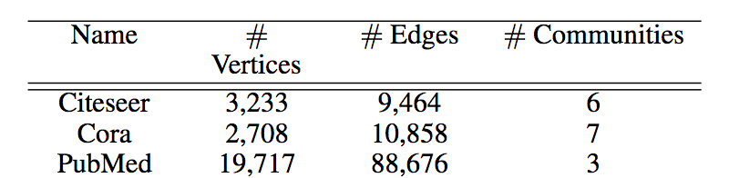

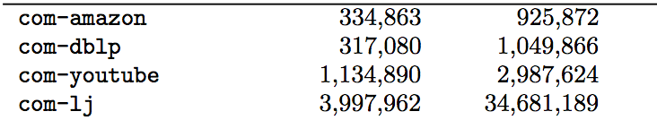

Preprocessing:

You may first sample the largest connected components of each graph to work on. For those four large graphs, you may focus on high-quality communities: Communities size greater than 100.

Regarding the performance:

**Results from “Optimizing Generalized PageRank Methods forSeed-Expansion Community Detection,” Li et al. NeurIPS 2019.**

For the three small graphs, Cora/Citeseer/PubMed, see the performance of different PageRank methods in the following figures (from left to right, Citeseer, Cora, PubMed). You may want to collect very long-hop random walks to achieve best community detection performance. The metric “Recall” indicates that if the community is of size C, what’s the portion of top-C ranked nodes that belong to this community. The x-axis refers to the steps of random walks that one collects. For PPR, the performance usually converges when you have 20 random-walk steps. However, the best performance can be achieved when you use IPR, termed inverse pagerank, that one emphasizes more on the large steps of random walks, specifically 0.99^{-k} for k-step. 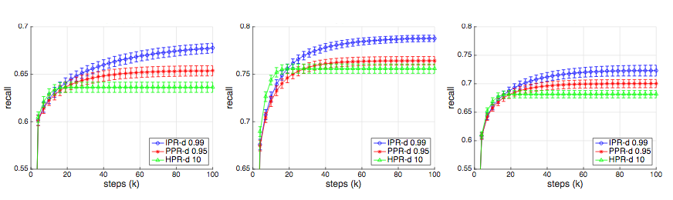

For two large networks (see the following), it seems that heat kernel PR gives the best results with limited number of random walk steps (say 5). 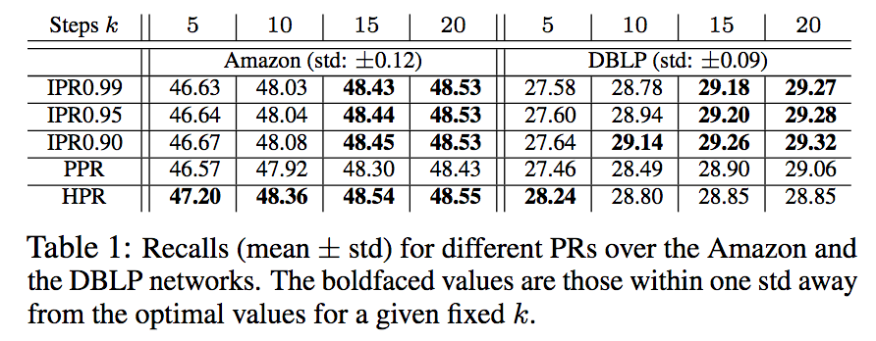

A similar result (the following table) is also observed in **“Heat Kernel Based Community Detection”, Kloster and Gleich, KDD 2014.**

F1-measure is more important for our setting, which is another metric different from the previous one.

